
Introduction To AI
Submitted By : Shamama Syed
Submitted To: Sir Irshad ullah
Registration No: 24JZELE0563
Section: Ai
Semester: 3RD

Assigment 02:

- Load the CSV manually
  - Use the csv module
  - Store each column separately:
    - days = []
    - hours = []
    - consumptions = []
- Group consumption by hour (manual group-by)
Create a dictionary like:
{ 1: [200, 700, 800, 500],
2: [300, 600, 700, 400],
3: [500, 400, 600, 650] }
  - Compute average consumption per hour
  - Compute peak consumption per hour
  - Print results in a neat format
- Group consumption by day
  - Create a dictionary like:
{ 7: [200,300,500,700,600,400],
8: [800,700,600,500,400,650] }
  - Compute total consumption per day
  - Compute daily average.

Program:
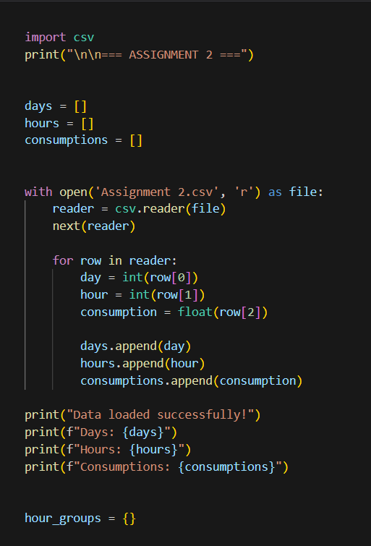

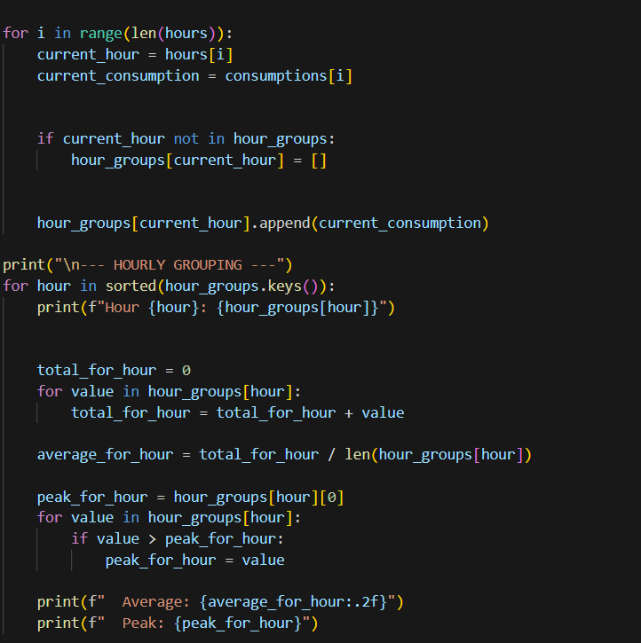

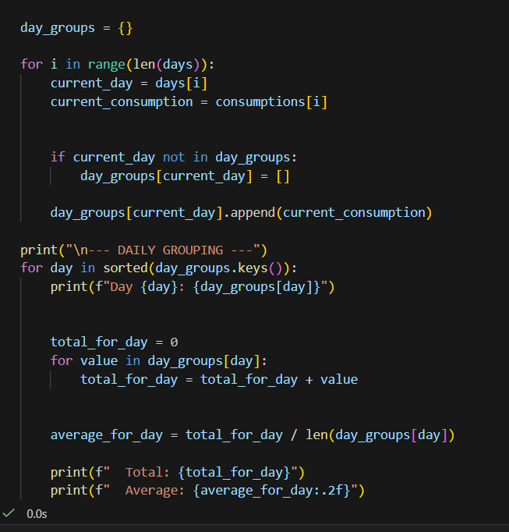

Output:
